Lab - Examining Telnet and SSH in Wireshark

1. Topology

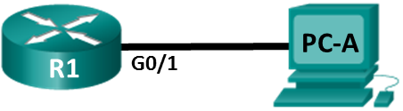

1. Addressing Table

|  |  |  |  |  |
| --- | --- | --- | --- | --- |
| Device | Interface | IP Address | Subnet Mask | Default Gateway |
| R1 | G0/1 | 192.168.1.1 | 255.255.255.0 | N/A |
| PC-A | NIC | 192.168.1.3 | 255.255.255.0 | 192.168.1.1 |

1. Objectives

Part 1: Configure the Devices for SSH Access

Part 2: Examine a Telnet Session with Wireshark

Part 3: Examine a SSH Session with Wireshark

1. Background / Scenario

In this lab, you will configure a router to accept SSH connectivity, and use Wireshark to capture and view Telnet and SSH sessions. This will demonstrate the importance of encryption with SSH.

**Note**: The routers used with CCNA hands-on labs are Cisco 1941 Integrated Services Routers (ISRs) with Cisco IOS Release 15.2(4)M3 (universalk9 image). The switches used are Cisco Catalyst 2960s with Cisco IOS Release 15.0(2) (lanbasek9 image). Other routers, switches, and Cisco IOS versions can be used. Depending on the model and Cisco IOS version, the commands available and output produced might vary from what is shown in the labs. Refer to the Router Interface Summary Table at the end of this lab for the correct interface identifiers.

**Note**: Make sure that the routers and switches have been erased and have no startup configurations. If you are unsure, contact your instructor.

1. Required Resources

* 1 Router (Cisco 1941 with Cisco IOS Release 15.2(4)M3 universal image or comparable)
* 1 PC (Windows 7 or 8 with terminal emulation program, such as Tera Term, and Wireshark installed)
* Console cables to configure the Cisco IOS devices via the console ports
* Ethernet cables as shown in the topology

1. Configure the Devices for SSH Access

In Part 1, you will set up the network topology and configure basic settings, such as the interface IP addresses, device access, and passwords on the router.

* 1. Cable the network as shown in the topology.
  2. Initialize and reload the router.
  3. Configure the basic settings on the router.
     1. Console into the router and enable privileged EXEC mode.
     2. Enter configuration mode.
     3. Configure device name as listed in the Addressing Table.
     4. Disable DNS lookup to prevent the router from attempting to translate incorrectly entered commands as though they were host names.
     5. Assign **class** as the privileged EXEC encrypted password.
     6. Assign **cisco** as the console password and enable login.
     7. Assign **cisco** as the VTY password and enable login.
     8. Encrypt the plain text passwords.
     9. Create a banner that will warn anyone accessing the device that unauthorized access is prohibited.
     10. Configure and activate the G0/1 interface using the information contained in the Addressing Table.
  4. Configure R1 for SSH access.
     1. Configure the domain for the device.

R1(config)# **ip domain-name ccna-lab.com**

* + 1. Configure the encryption key method.

R1(config)# **crypto key generate rsa modulus 1024**

* + 1. Configure a local database username.

R1(config)# **username admin privilege 15 secret adminpass**

* + 1. Enable Telnet and SSH on the VTY lines.

R1(config)# **line vty 0 4**

R1(config-line)# **transport input telnet ssh**

* + 1. Change the login method to use the local database for user verification.

R1(config-line)# **login local**

R1(config-line)# **end**

* 1. Save the running configuration to the startup configuration file.
  2. Configure PC-A.
     1. Configure PC-A with an IP address and subnet mask.
     2. Configure a default gateway for PC-A.
  3. Verify network connectivity.

Ping R1 from PC-A. If the ping fails, troubleshoot the connection.

1. Examine a Telnet Session with Wireshark

In Part 2, you will use Wireshark to capture and view the transmitted data of a Telnet session on the router. You will use Tera Term to telnet to R1, sign in, and then issue the **show run** command on the router.

**Note**: If a Telnet/SSH client software package is not installed on your PC, you must install one before continuing. Two popular freeware Telnet/SSH packages are Tera Term (<http://download.cnet.com/Tera-Term/3000-20432_4-75766675.html>) and PuTTY ([www.putty.org](http://www.putty.org)).

**Note**: Telnet is not available from the command prompt inWindows 7, by default. To enable Telnet for use in the command prompt window, click **Start** > **Control Panel** > **Programs** > **Programs and Features** > **Turn Windows features on or off**. Click the **Telnet Client** check box, and then click **OK**.

* 1. Capture data.
     1. Start Wireshark.
     2. Start capturing data on the LAN interface.

**Note**: If you are unable to start the capture on the LAN interface, you may need to open Wireshark using the **Run as Administrator** option.

* 1. Start a Telnet session to the router.
     1. Open Tera Term and select the **Telnet** Service radio button and in the Host field, enter **192.168.1.1**.

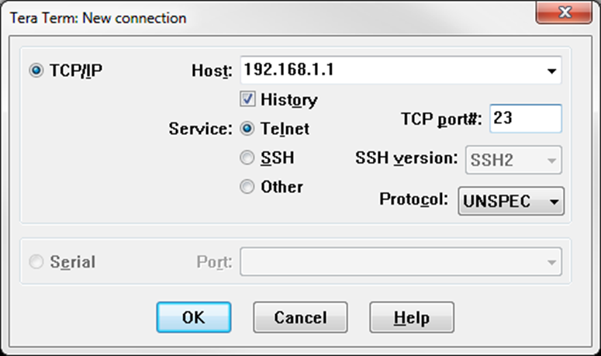

What is the default TCP port for Telnet sessions? _________________

* + 1. At the Username: prompt, enter **admin** and at the Password: prompt, enter **adminpass**. These prompts are generated because you configured the VTY lines to use the local database with the **login local** command.

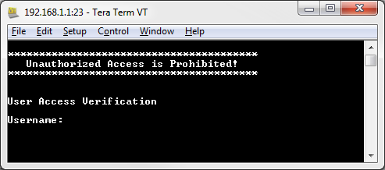

* + 1. Issue the **show run** command.

R1# **show run**

* + 1. Enter **exit** to exit the Telnet session and out of Tera Term.

R1# **exit**

* 1. Stop the Wireshark capture.
  2. Apply a Telnet filter on the Wireshark capture data.



* 1. Use the Follow TCP Stream feature in Wireshark to view the Telnet session.
     1. Right-click one of the **Telnet** lines in the **Packet list** section of Wireshark, and from the drop-down list, select **Follow TCP Stream**.

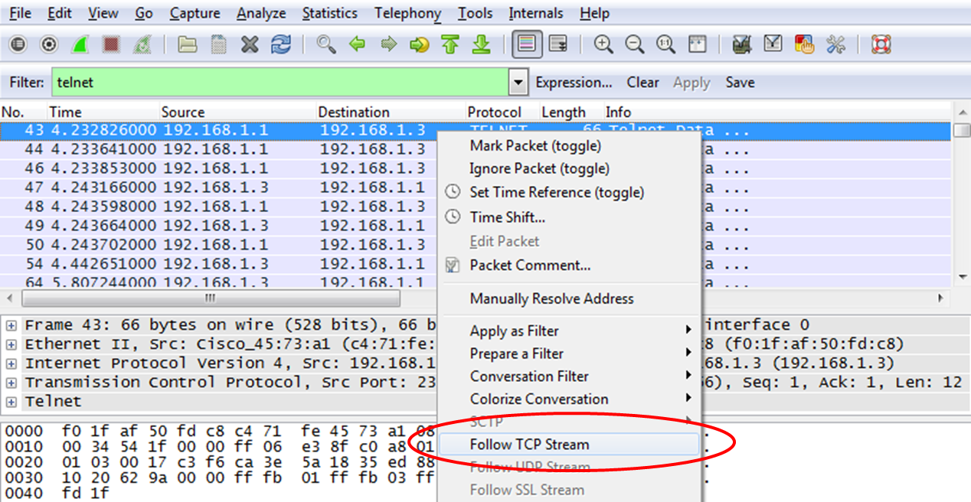

* + 1. The Follow TCP Stream window displays the data for your Telnet session with the router. The entire session is displayed in clear text, including your password. Notice that the username and **show run** command that you entered are displayed with duplicate characters. This is caused by the echo setting in Telnet to allow you to view the characters that you type on the screen.

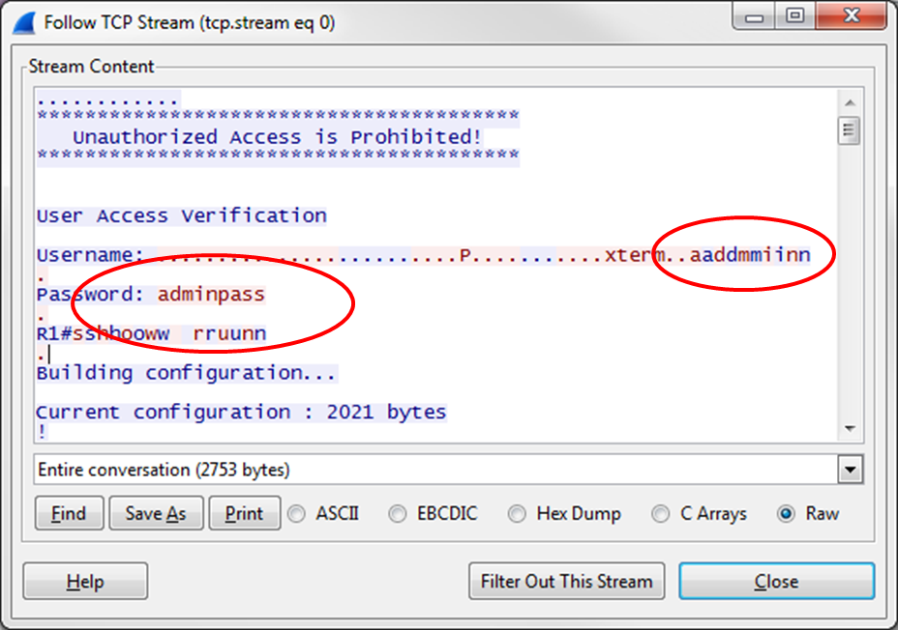

* + 1. After you have finished reviewing your Telnet session in the **Follow TCP Stream** window, click **Close**.

1. Examine an SSH Session with Wireshark

In Part 4, you will use the Tera Term software to establish an SSH session with the router. Wireshark will be used to capture and view the data of this SSH session.

* 1. Open Wireshark and start capturing data on the LAN interface.
  2. Start an SSH session on the router.
     1. Open Tera Term and enter the G0/1 interface IP address of R1 in the Host: field of the Tera Term: New Connection window. Ensure that the **SSH** radio button is selected and then click **OK** to connect to the router.

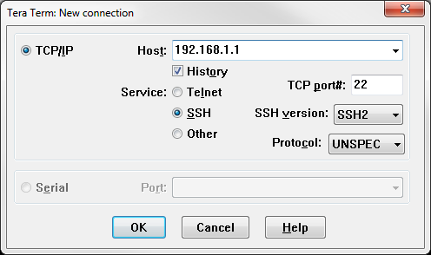

What is the default TCP port used for SSH sessions? __________________

* + 1. The first time you establish a SSH session to a device, a **SECURITY WARNING** is generated to let you know that you have not connected to this device before. This message is part of the authentication process. Read the security warning and click **Continue**.

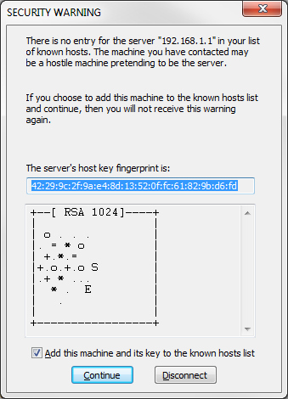

* + 1. In the SSH Authentication window, enter **admin** for the username and **adminpass** for the passphrase. Click **OK** to sign into the router.

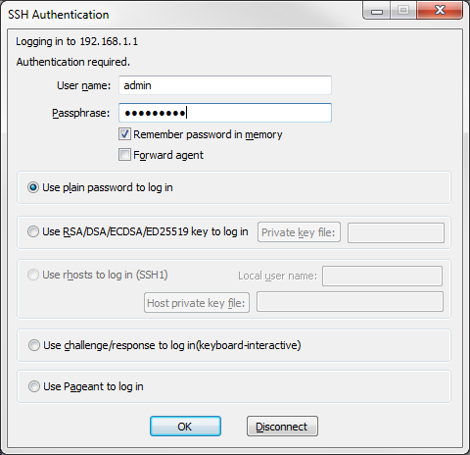

* + 1. You have established an SSH session on the router. The Tera Term software looks very similar to a command window. At the command prompt, issue the **show run** command.

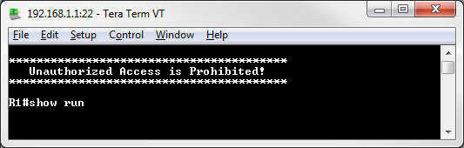

* + 1. Exit the SSH session by issuing the **exit** command.

R1# **exit**

* 1. Stop the Wireshark capture.
  2. Apply an SSH filter on the Wireshark Capture data.



* 1. Use the Follow TCP Stream feature in Wireshark to view the SSH session.
     1. Right-click one of the **SSHv2** lines in the **Packet list** section of Wireshark, and in the drop-down list, select the **Follow TCP Stream** option.
     2. Examine the **Follow TCP Stream** window of your SSH session. The data has been encrypted and is unreadable. Compare the data in your SSH session to the data of your Telnet session.

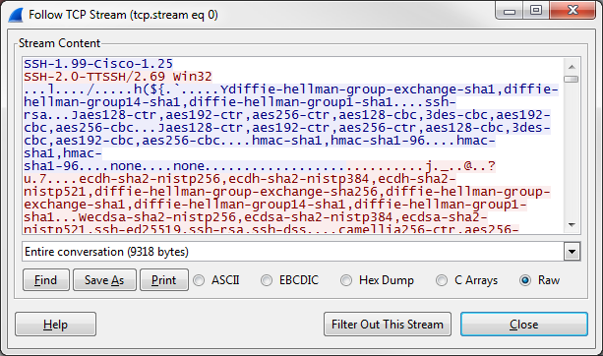

Why is SSH preferred over Telnet for remote connections?

____________________________________________________________________________________

____________________________________________________________________________________

* + 1. After examining your SSH session, click **Close**.
    2. Close Wireshark.

1. Reflection

How would you provide multiple users, each with their own username, access to a network device?

_______________________________________________________________________________________

1. Router Interface Summary Table

|  |  |  |  |  |
| --- | --- | --- | --- | --- |
| Router Interface Summary | | | | |
| Router Model | Ethernet Interface #1 | Ethernet Interface #2 | Serial Interface #1 | Serial Interface #2 |
| 1800 | Fast Ethernet 0/0 (F0/0) | Fast Ethernet 0/1 (F0/1) | Serial 0/0/0 (S0/0/0) | Serial 0/0/1 (S0/0/1) |
| 1900 | Gigabit Ethernet 0/0 (G0/0) | Gigabit Ethernet 0/1 (G0/1) | Serial 0/0/0 (S0/0/0) | Serial 0/0/1 (S0/0/1) |
| 2801 | Fast Ethernet 0/0 (F0/0) | Fast Ethernet 0/1 (F0/1) | Serial 0/1/0 (S0/1/0) | Serial 0/1/1 (S0/1/1) |
| 2811 | Fast Ethernet 0/0 (F0/0) | Fast Ethernet 0/1 (F0/1) | Serial 0/0/0 (S0/0/0) | Serial 0/0/1 (S0/0/1) |
| 2900 | Gigabit Ethernet 0/0 (G0/0) | Gigabit Ethernet 0/1 (G0/1) | Serial 0/0/0 (S0/0/0) | Serial 0/0/1 (S0/0/1) |
| **Note**: To find out how the router is configured, look at the interfaces to identify the type of router and how many interfaces the router has. There is no way to effectively list all the combinations of configurations for each router class. This table includes identifiers for the possible combinations of Ethernet and Serial interfaces in the device. The table does not include any other type of interface, even though a specific router may contain one. An example of this might be an ISDN BRI interface. The string in parenthesis is the legal abbreviation that can be used in Cisco IOS commands to represent the interface. | | | | |